**QUESTION:**

Create this form

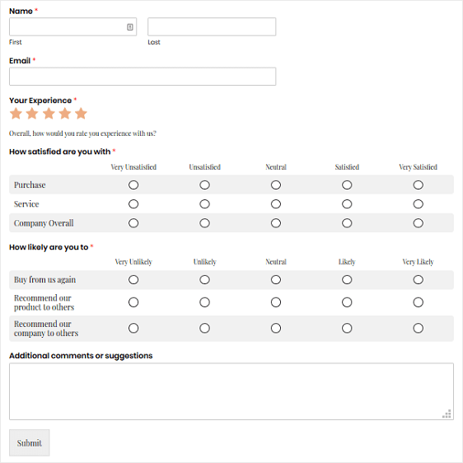

**CODE:**

**Index.html**

<!DOCTYPE html>

<!--HTML 5-->

<html lang="en">

  <head>

    <meta charset="UTF-8" />

    <meta http-equiv="X-UA-Compatible" content="IE=edge" />

    <meta name="viewport" content="width=device-width, initial-scale=1.0" />

   <link rel = "stylesheet" href="style.css">

    <title>Document</title>

  </head>

  <body>

    <form action="#" method="post">

      <div  class="form1">

        <!-------------------------------------------------------------------------------------------------------->

        <label class="bold form-ele" for="firstname">Name<span class="colored-text">*</span></label>

        <br>

          <input type="text" class="col3 form-ele" id="firstname"/>

        <input type="text" class="col3" id="lastname"/>

        <br>

        <div class="col12">

          <label class="text-left form-ele" for="firstname" >First</label>

          <label class="text-left " for="lastname" >Last</label>

        </div>

        <!-------------------------------------------------------------------------------------------------------->

        <br><br>

        <label for="email" class="bold form-ele">Email<span class="colored-text">*</span></label>

        <br>

        <input type="text" class="col6 form-ele" id="email" />

        <br><br>

        <!-------------------------------------------------------------------------------------------------------->

        <label class="bold form-ele" for="3-stars">Your Experience<span class="colored-text">*</span></label>

        <div class="star-rating form-ele">

          <input type="radio" id="5-stars" name="rating" value="5" />

          <label for="5-stars" class="star">&#9733;</label>

          <input type="radio" id="4-stars" name="rating" value="4" />

          <label for="4-stars" class="star">&#9733;</label>

          <input type="radio" id="3-stars" name="rating" value="3" />

          <label for="3-stars" class="star">&#9733;</label>

          <input type="radio" id="2-stars" name="rating" value="2" />

          <label for="2-stars" class="star">&#9733;</label>

          <input type="radio" id="1-star" name="rating" value="1" />

          <label for="1-star" class="star">&#9733;</label>

        </div>

        <div class="form-ele">Overall how would you rate you experience with us</div>

        <br><br>

        <!-------------------------------------------------------------------------------------------------------->

        <label class="bold form-ele" >How satisfied are you with<span class="colored-text">*</span></label>

       <!-- Making the table responsive -->

    <div style="overflow-x: auto;">

      <!-- Adding table  -->

      <table class="col12 form-ele" cellspacing="5" cellpadding="5">

        <!--Make table width 100% and then divide to different columns of width 16.66%-->

        <col class="col2" />

        <col  class="col2"/>

        <col class="col2" />

        <col class="col2"/>

        <col class="col2" />

        <col class="col2" />

        <tr>

          <th></th>

          <th>Very Unsatisfied</th>

          <th>Unsatisfied</th>

          <th>Neutral</th>

          <th>Satisfied</th>

          <th>Very satisfied</th>

        </tr>

        <tr class="color-table">

          <td>Purchase</td>

          <td class="radio-center"><input type="radio" name="purchase-r"/></td>

          <td class="radio-center"><input type="radio" name="purchase-r"/></td>

          <td class="radio-center"><input type="radio" name="purchase-r"/></td>

          <td class="radio-center"><input type="radio" name="purchase-r"/></td>

          <td class="radio-center"><input type="radio" name="purchase-r"/></td>

        </tr>

        <tr>

          <td>Service</td>

          <td class="radio-center"><input type="radio" name="service-r"/></td>

          <td class="radio-center"><input type="radio" name="service-r"/></td>

          <td class="radio-center" ><input type="radio" name="service-r"/></td>

          <td class="radio-center"><input type="radio" name="service-r"/></td>

          <td class="radio-center"><input type="radio" name="service-r"/></td>

        </tr>

        <tr class="color-table">

          <td >Company overall</td>

          <td class="radio-center"><input type="radio" name="overall-r"/></td>

          <td class="radio-center"><input type="radio" name="overall-r"/></td>

          <td class="radio-center"><input type="radio" name="overall-r"/></td>

          <td class="radio-center"><input type="radio" name="overall-r"/></td>

          <td class="radio-center"><input type="radio" name="overall-r"/></td>

        </tr>

      </table>

    </div>

    <br><br>

    <!-------------------------------------------------------------------------------------------------------->

    <label class="bold form-ele">How likely are you to<span class="colored-text">*</span></label>

    <div style="overflow-x: auto;">

      <!-- Adding table  -->

      <table class="col12 form-ele" cellspacing="5" cellpadding="5">

        <!--Make table width 100% and then divide to different columns of width 16.66%-->

        <col class="col2" />

        <col  class="col2"/>

        <col class="col2" />

        <col class="col2"/>

        <col class="col2" />

        <col class="col2" />

        <tr>

          <th></th>

          <th>Very Unsatisfied</th>

          <th>Unsatisfied</th>

          <th>Neutral</th>

          <th>Satisfied</th>

          <th>Very satisfied</th>

        </tr>

        <tr class="color-table">

          <td>Buy from us again</td>

          <td class="radio-center"><input type="radio" name="buyagain-r"/></td>

          <td class="radio-center"><input type="radio" name="buyagain-r"/></td>

          <td class="radio-center"><input type="radio" name="buyagain-r"/></td>

          <td class="radio-center"><input type="radio" name="buyagain-r"/></td>

          <td class="radio-center"><input type="radio" name="buyagain-r"/></td>

        </tr>

        <tr>

          <td>Recommend our product to others</td>

          <td class="radio-center"><input type="radio" name="recommendpdt-r"/></td>

          <td class="radio-center"><input type="radio" name="recommendpdt-r"/></td>

          <td class="radio-center"><input type="radio" name="recommendpdt-r"/></td>

          <td class="radio-center"><input type="radio" name="recommendpdt-r"/></td>

          <td class="radio-center"><input type="radio" name="recommendpdt-r"/></td>

        </tr>

        <tr class="color-table">

          <td >Recommend our company to others</td>

          <td class="radio-center"><input type="radio" name="recommendcom-r"/></td>

          <td class="radio-center"><input type="radio" name="recommendcom-r"/></td>

          <td class="radio-center"><input type="radio" name="recommendcom-r"/></td>

          <td class="radio-center"><input type="radio" name="recommendcom-r"/></td>

          <td class="radio-center"><input type="radio" name="recommendcom-r"/></td>

        </tr>

      </table>

    </div>

  <br><br>

  <!-------------------------------------------------------------------------------------------------------->

        <label class="bold form-ele">Additional comments or suggestions</label>

        <br>

        <textarea  id="texta1" class="col12 form-ele"></textarea>

        <!-------------------------------------------------------------------------------------------------------->

        <br><br>

        <input type="submit" class="button form-ele"/>

        <!-------------------------------------------------------------------------------------------------------->

      </div>

    </form>

  </body>

  <!-- lodash.js is downloaded and placed in current folder -->

  <script src="./lodash.js"></script>

  <script src="./script.js"></script>

</html>

**Style.css**

body{

    margin-left: 1%;

    margin-right: 1%;

    margin-top: 3%;

}

.form1{

    background-color: cornsilk;

}

.form-ele{

    margin-left: 1%;

    margin-right: 2%;

}

table,th,td {

border-collapse: collapse; /*border for table is removed/collapsed*/

}

table.fixed {

    table-layout: fixed;

}

table.fixed td {

    overflow: hidden;

}

.radio-center{

    text-align: center;

}

th{

    font-weight: 100;

    color: darkgray;

}

#texta1{

    height:100px;

}

.colored-text{

    color: red;

}

.bold{

    font-weight: bold;

    font-family: 'Franklin Gothic Medium', 'Arial Narrow', Arial, sans-serif;

}

.button{

    width: 5%;

    height: 60px;

}

.color-table{

    background-color:gainsboro;

}

.radio{

    text-align: center;

}

.text-left{

    display:inline-block;

    text-align: left;

    width: 26%;

}

.row{

    width: 100%;

}

.col1{

    width: 8.16%;

}

.col2{

    width: 16.32%;

}

.col3{

    width: 24.48%;

}

.col4{

    width: 32.62%;

}

.col5{

    width: 40.8%;

}

.col6{

    width: 51.4%;

}

.col7{

    width: 57.12%;

}

.col8{

    width: 65.28%;

}

.col9{

    width: 73.44%;

}

.col10{

    width: 81.6%;

}

.col11{

  width:  89.76%;

}

.col12{

    width: 98%;

}

/*STAR RATING

*/

/*Radio buttons(input) and stars(label) are ctreated from HTML -> Both linked using for(label) and id(input) */

/*Increase size and position the stars*/

.star-rating {

    display:flex;

    flex-direction: row-reverse; /*direction for choosing stars when hovered*/

    font-size:2em;

    justify-content:space-around;

    text-align:center;

    width:5em;

  }

  /*The radio button display is made none*/

  .star-rating input {

    display:none;

  }

  /*initial color for star*/

  .star-rating label {

    color:#ccc;

    cursor:pointer;

  }

/*change color when checked or hovered*/

  .star-rating :checked ~ label {

    color:#f90;

  }

  .star-rating label:hover,

  .star-rating label:hover ~ label {

    color:#fc0;

  }

**OUTPUT:**

